**Ex 18-1 #1:**

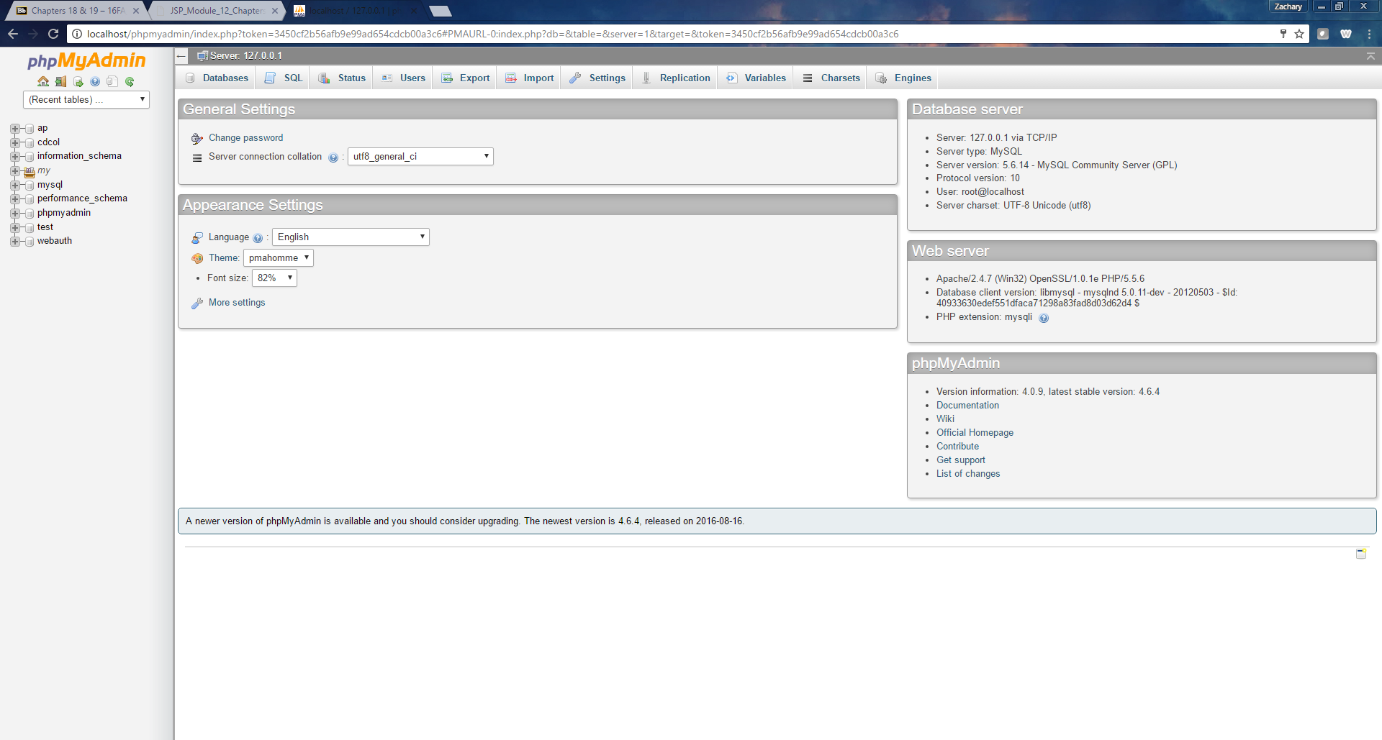

Successfully started phpMyAdmin

**Ex 18-1 #2&3:**

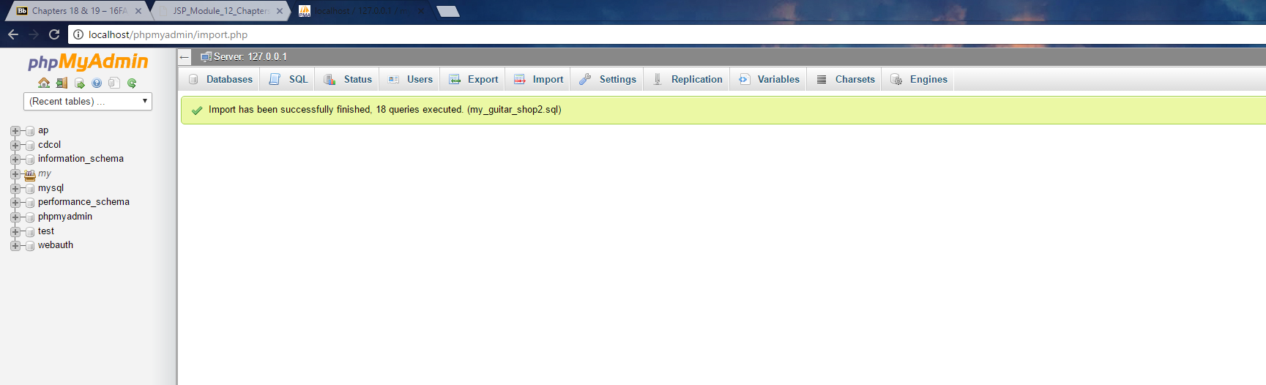

Ran script successfully.

**Ex 18-1 # 4:**

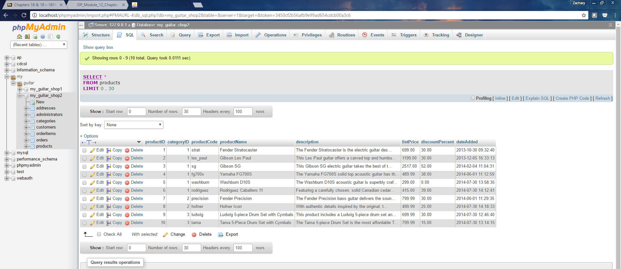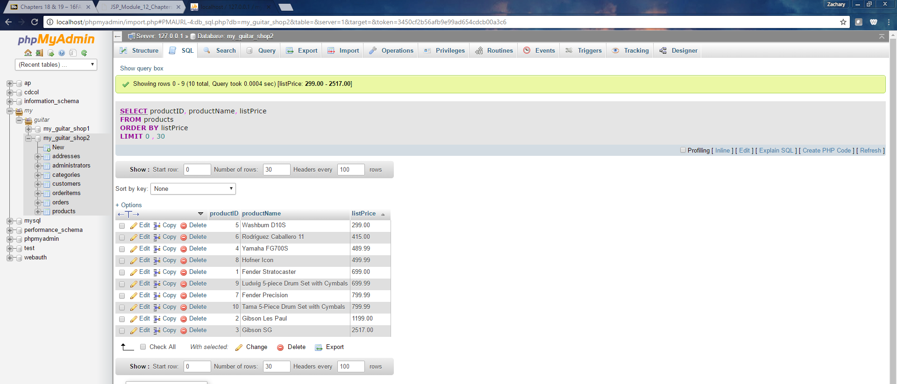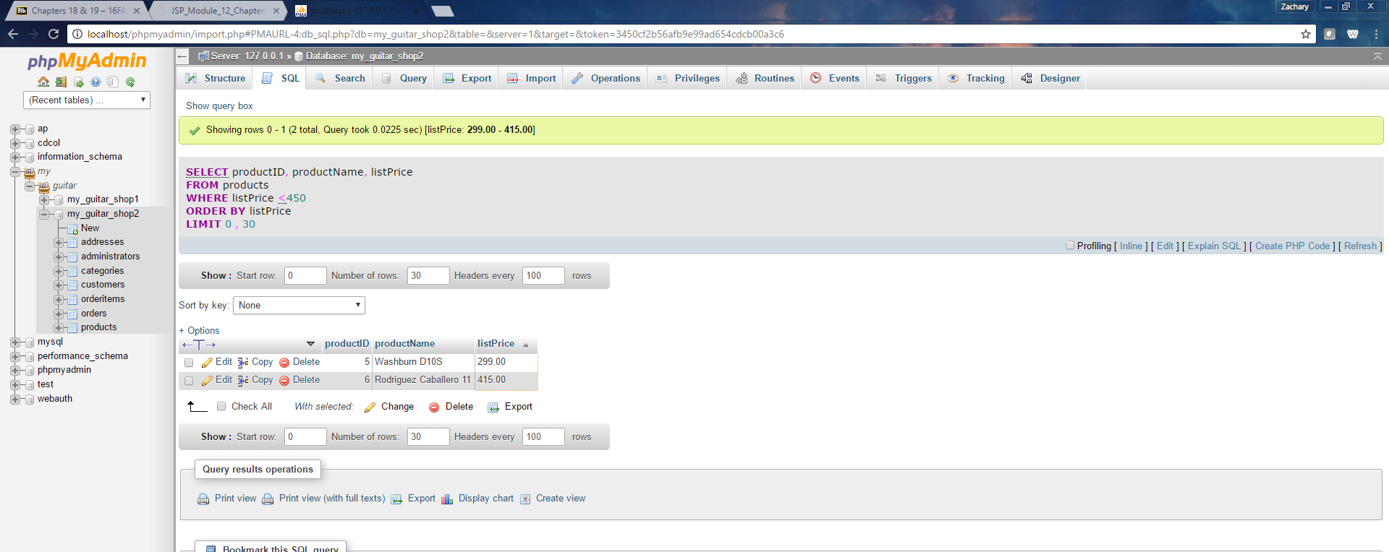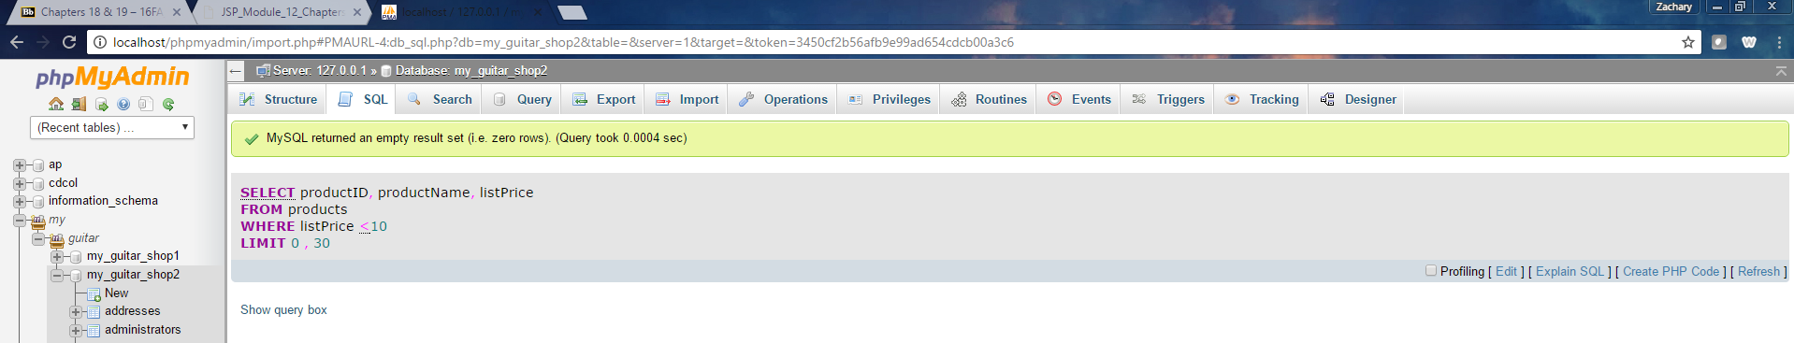

Able to run all three of these SELECT statements.

**Ex 18-1 #5:**

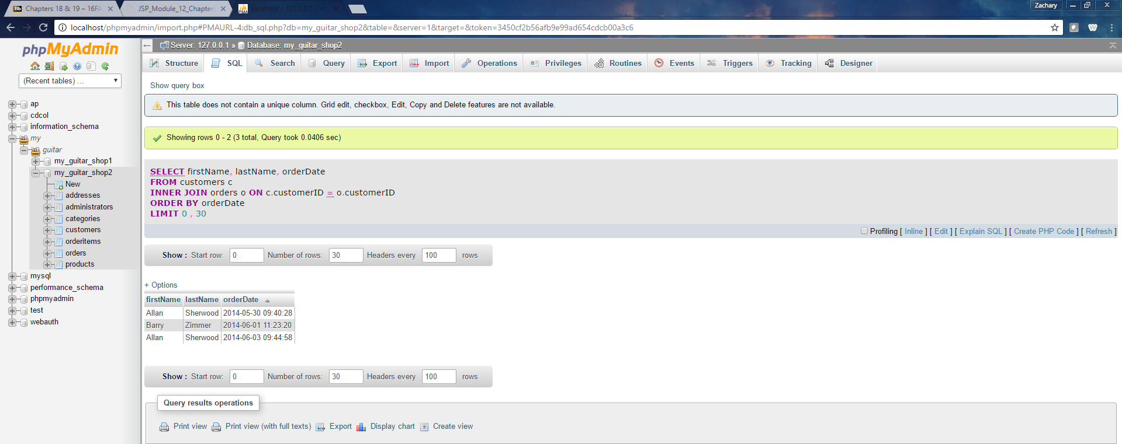

Able to run script.

**Ex 18-1 #6:**

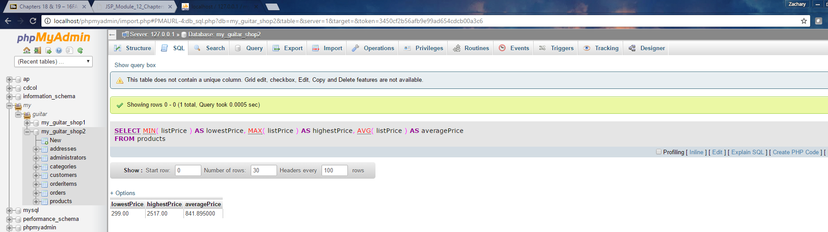

Ran other example statement that I was interested in.

**Ex 18-1 #7:**

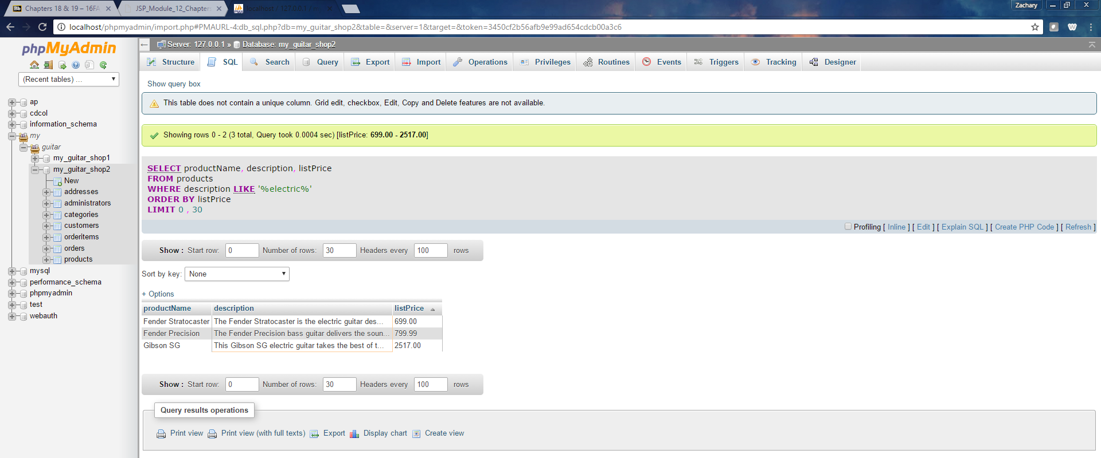

Ran this SELECT statement successfully.

**Ex 18-1 #8:**

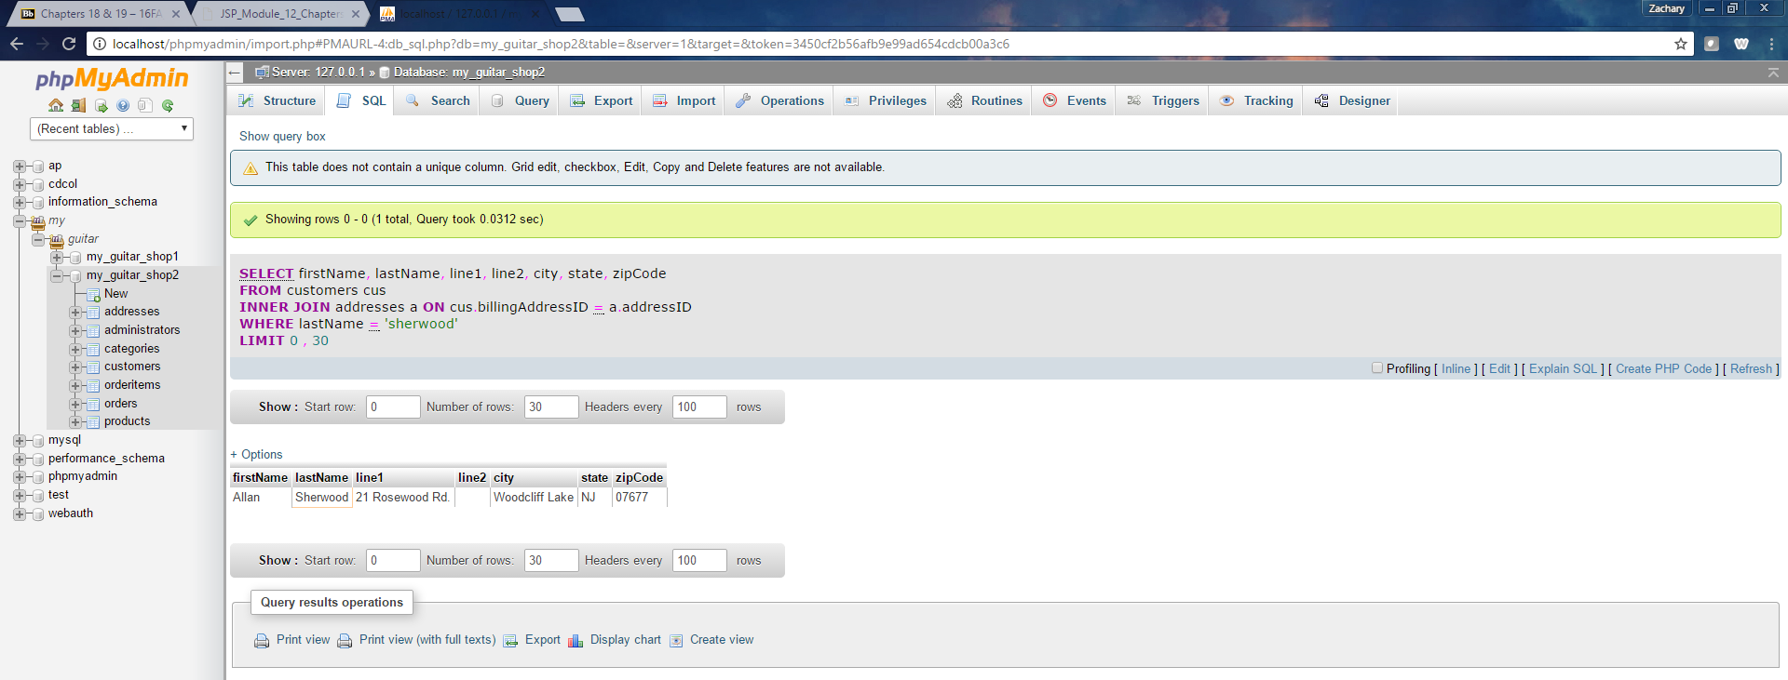

Able to run SELECT script successfully.

**Ex 18-1 # 9:**

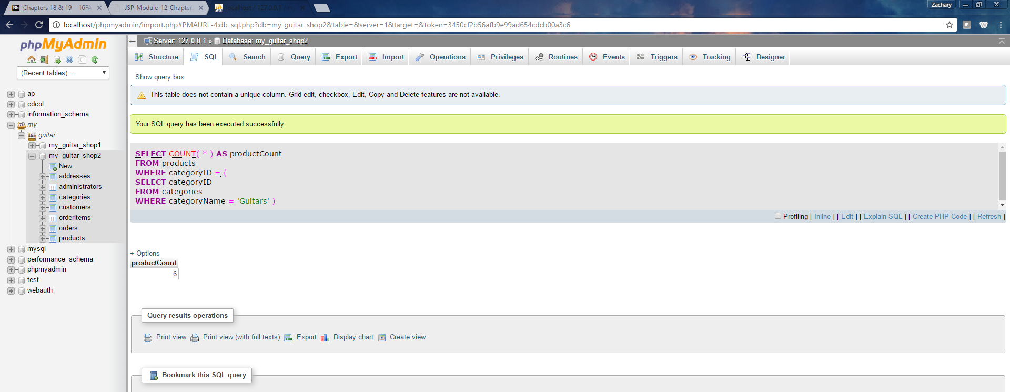

Ran COUNT SELECT statement successfully.

**Ex 18-1 # 10:**

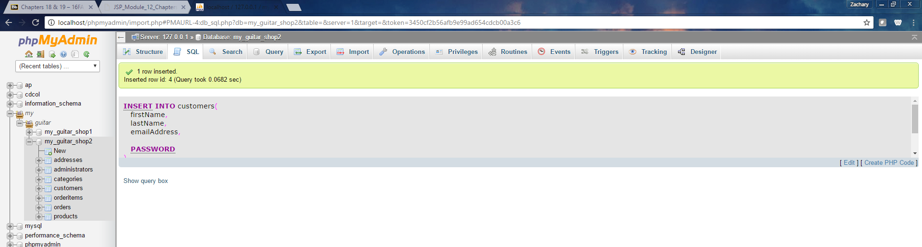

INSERT statement ran successfully.

**Ex 18-1 # 11:**

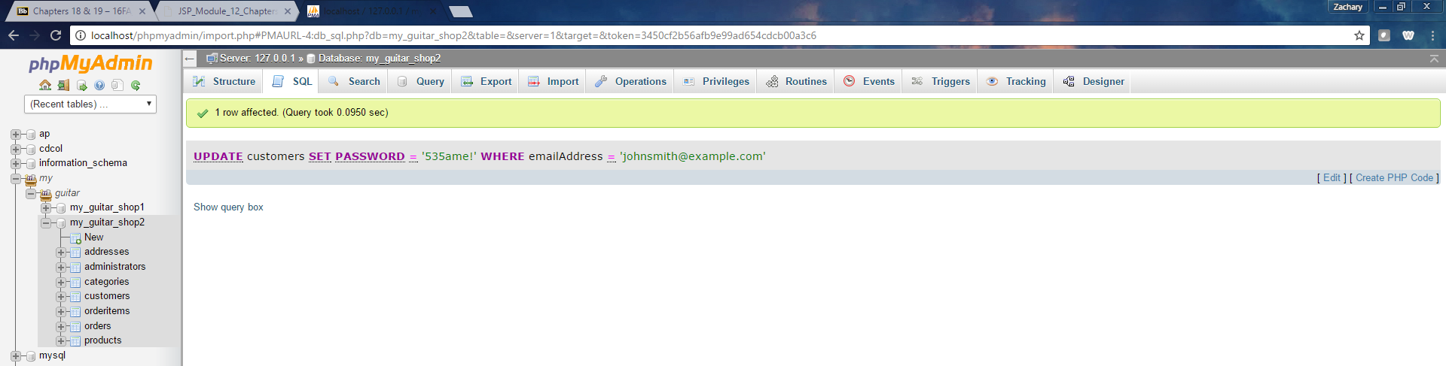

Ran UPDATE statement successfully.

**Ex 18-1 # 12:**

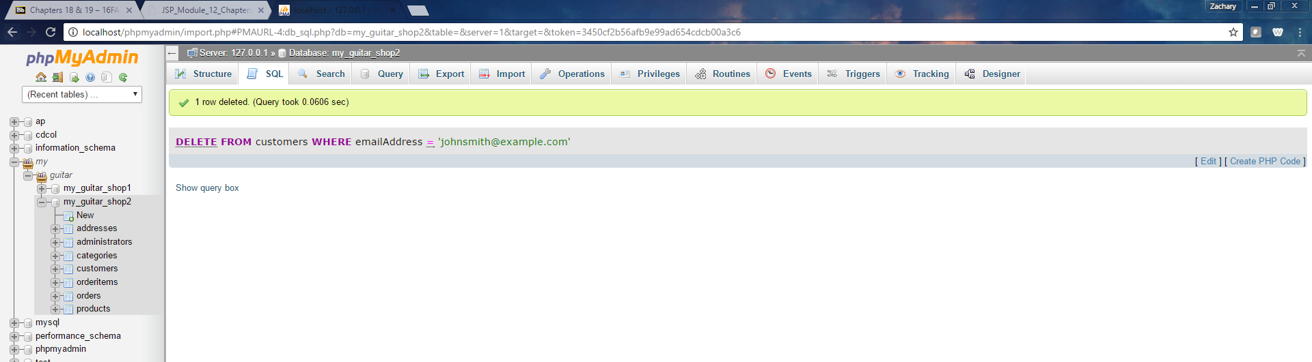

DELETE statement ran successfully.

**Ex 18-1 # 13:**

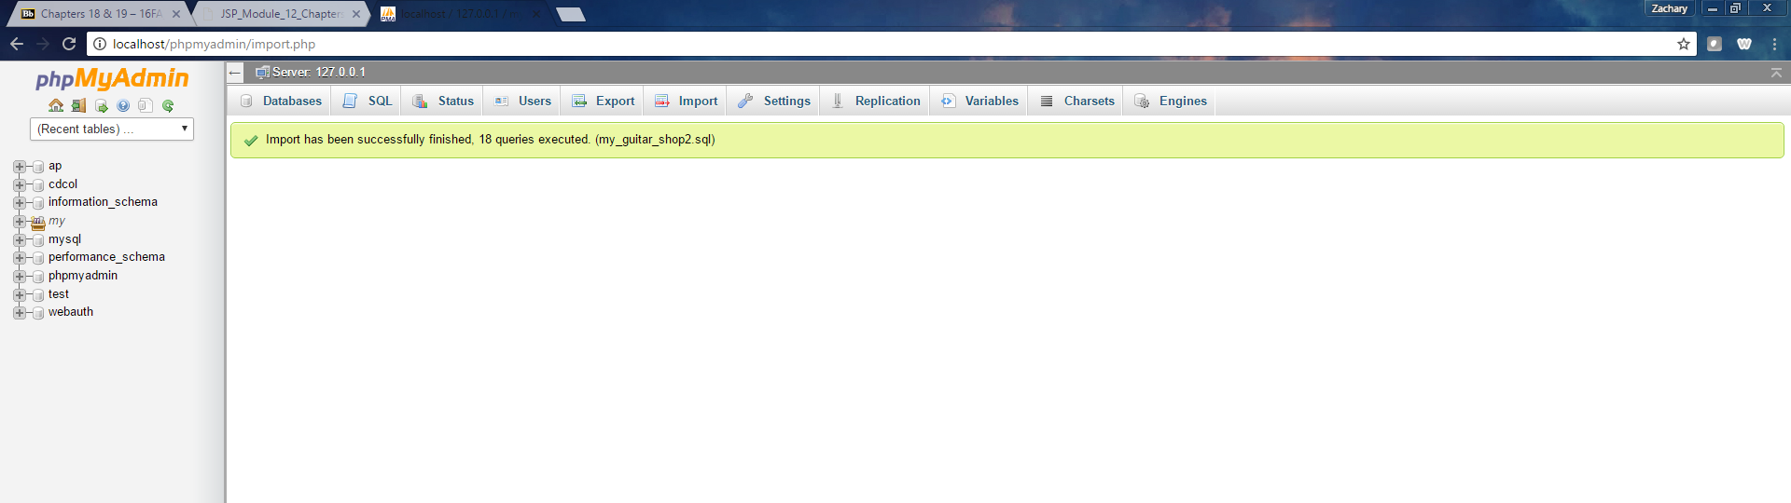

Restored database back.